Activity 1.1.7 - Traversing Turtles

CSP Period 5 - 9/15/21

Kyle Huang

18.

| import turtle as trtl  import math  # create an empty list of turtles  my_turtles = []  # use interesting shapes and colors  turtle_shapes = ["arrow", "turtle", "circle", "square", "triangle", "classic"]  turtle_colors = ["red", "blue", "green", "orange", "purple", "gold"]  for s in turtle_shapes:  t = trtl.Turtle(shape=s)  color = turtle_colors[turtle_shapes.index(s)]  t.speed(0)  t.pencolor(color)  t.color(color)  my_turtles.append(t)  num_turtles = len(turtle_shapes)  i = 0  while (True):  iterations = math.floor(i/8)  t = my_turtles[i%6]  t.penup()  t.setheading(0)  t.goto(25*iterations, 50*iterations + math.sqrt(2*((25*iterations)^2)))  t.pendown()  for j in range(i%8):  t.right(45)  t.forward(50*(iterations+1))  t.stamp()  i += 1  wn = trtl.Screen()  wn.mainloop() |
| --- |

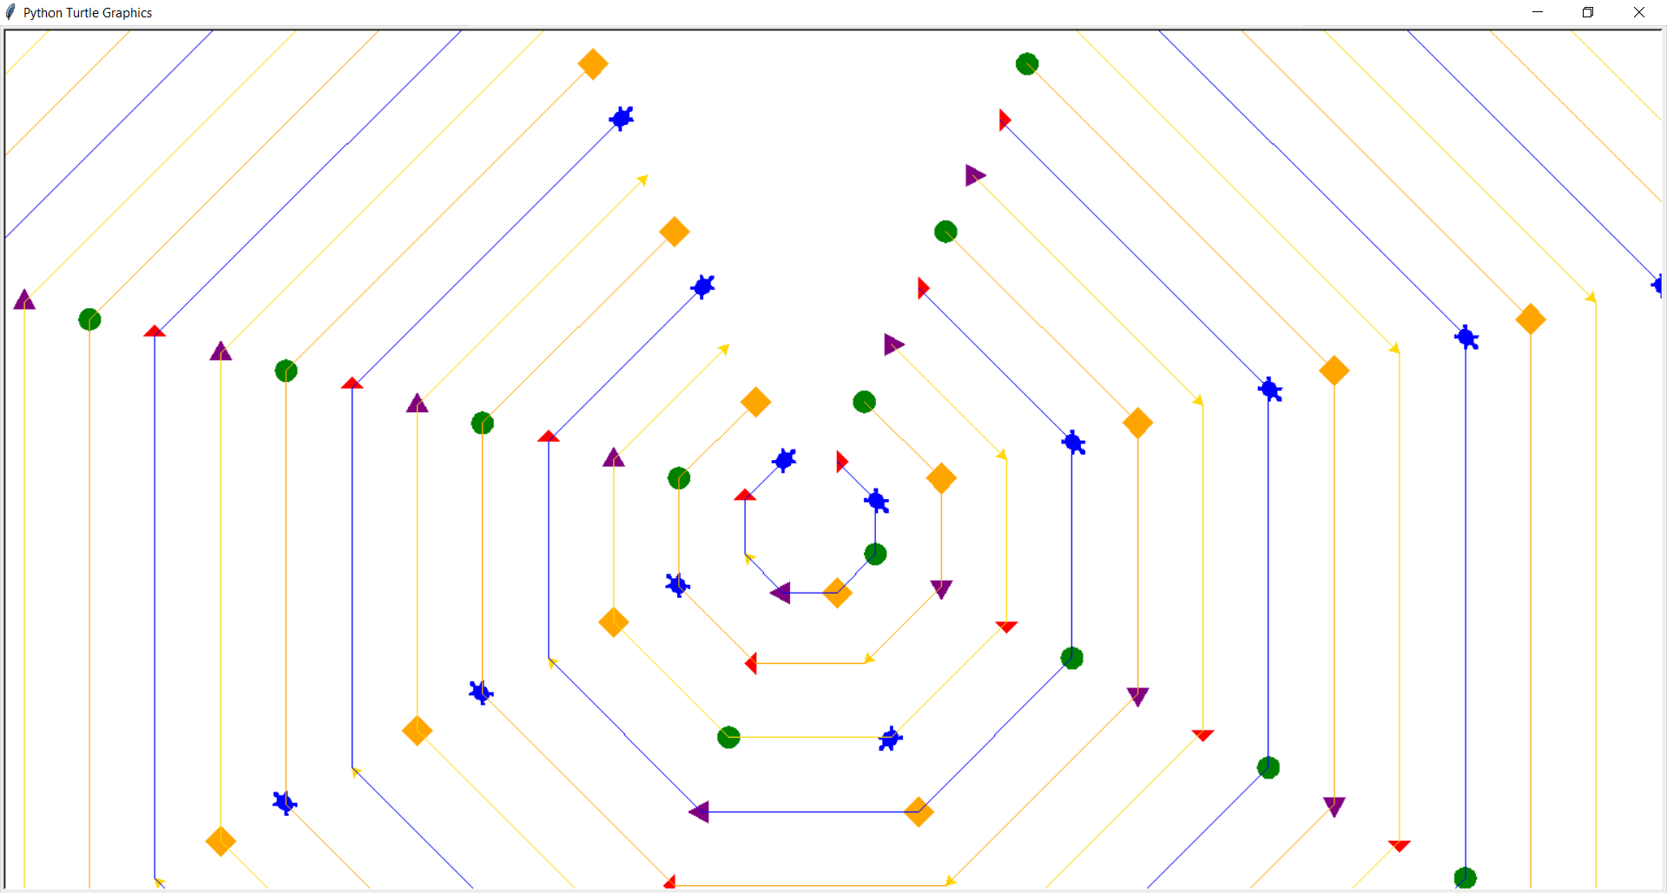

Conclusion Questions

In what situations would lists be used instead of single variables?

Lists can be used instead of single variables when there are multiple variables of the same type that need to be kept track of and possibly iterated through. Additionally, lists can be used when the number of variables is unknown or changing, as, theoretically, there can be infinite variables in a list, while it is impossible to manually initialize an infinite number of variables.

What are some other types of elements that you didn't use in the activity that you think would be appropriate to represent in a list?

Integers, such as to keep track of a scoreboard, or other lists, to create nested lists that can store two-dimensional data, could also be represented with a list.